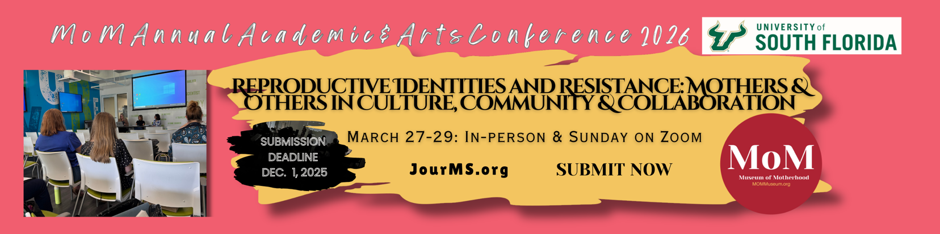 Reproductive Identities and Resistance: Mothers and Others in Culture, Community and Collaboration
Call for Presenters: The Annual International Academic & Arts MoM Conference
Conference Dates: March 27-29, 2026
Location: USF St. Pete campus & the Museum of Motherhood (MoM)
*Virtual presentation available on March 29, 2026 only
This year’s conference theme is grounded in Aurélie M. Athan’s concept of reproductive identity as a lifelong meaning-making process regarding how individuals orient themselves to reproduction, parenting, and caregiving, and the “if/when/how/who” associated with reproductive decision-making. As a concept, reproductive identity is fluid and resists pronatalist and patriarchal mandates that dictate narrow expectations about reproductive outcomes and parenting. It centers an individual’s lived experiences and associated meanings about all aspects of reproduction, including being childfree, pregnancy, infertility, abortion, pregnancy loss and grief, adoption, and extended family systems of caregiving.

The various and ever-changing meanings associated with reproduction (or reproductive potential) across the lifespan is paramount to understanding reproductive identity as a concept with emotional, spiritual, financial, familial, cultural, and political influences and implications. As a conference theme, we welcome work that shares interdisciplinary, feminist, holistic, developmental, and narrative inquiry with reproductive identity as a concept. We invite critical reflection and collective inquiry into how maternal, reproductive, and care-centered identities are formed, challenged, and transformed across contexts, relationships, and life stages. We seek work that explores these identities not only as individual journeys, but as deeply social, political, and communal acts.

This international call for papers, performances, panels, workshops, and creative projects welcomes contributions from across disciplines and practices—including scholars, artists, poets, sociologists, maternal psychologists, philosophers, anthropologists, gender and sexuality studies faculty, birth-workers, doulas, midwives, physicians, students, and community members. We encourage submissions from people of all backgrounds, particularly those from marginalized parenting and birthing experiences. We especially welcome work that uses innovative, decolonial, or creative research methodologies; amplifies underrepresented or silenced experiences of m/otherhood and birthing; engages in activist or community-based praxis for reproductive and birth justice; reclaims reproductive labor as power, protest, and possibility; and challenges binaries of parent/non-parent, gendered caregiver roles, and “good mother” ideologies.
Subthemes include (but are not limited to):
- Reproductive and Birth Justice Movements
- Black Maternal Health
- Intersectional M/Other Identities & (Dis)Abilities
- M/Othering Across the Lifespan: From Matrescence to Elderhood
- Artmaking and Creativity as Resistance
- The Messiness of M/Otherhood & M/Other Studies
- Care-giving and Care Labor in Families, Health Systems, and Beyond
- Authentic and Community-Based Forms of Healing
- Empowering M/others of All Kinds
- “Who Am I?”: Identity, Transformation, and the Self-in-Community
We welcome submissions from students. We will have special events geared toward students including mentoring sessions and a writing workshop!
Please do not hesitate to submit a proposal that falls outside our conference subthemes. We want to expand the dialogue around scholarship and art pertaining to Mother Studies, so if you think your proposal might be a good fit, we want to see it!
Formats may include in-person or virtual presentations, including the following:
- Academic Papers and Panels
- Performance Art or Spoken Word/Poetry Readings
- Visual Art Exhibits
- Storytelling or Narrative-Based Presentations
- Roundtables (Dialogues) or Workshops
- Moderators: We encourage individuals to submit their interest in moderating a panel presentation (in addition to or instead of submitting your own work); the submission portal will prompt you to include your area of expertise.

Submission Guidelines:
Please submit a 250 word abstract or project proposal, along with a short bio (100 words), and your preferred presentation format including your in-person or virtual participation by [insert deadline] to [insert email or submission portal]. Note that all virtual presentations will be scheduled for March 29, 2026.
The submission portal will require you to select your preferred presentation format (from the list above) and will require you to indicate if your attendance will be in person or virtual.
Notifications of Acceptance: January 2026; all presenters must be registered conference participants (either in person or virtually) to present at the conference.
We look forward to gathering to explore, challenge, and celebrate the multifaceted experiences of reproductive identity.

For more information, visit: JourMS.org / presented by www.mommuseum.org
Questions? Contact: Brittany DeNucci, conference planning committee chair The Museum of Motherhood @ membership@mommuseum.org or call 877-711-MOMS (6667) and leave a message. We will call or text you back!

Journal of Mother Studies – JourMS.org

